ASSIGNMENT – 4

Day 4 - Assignment

Overview of the Dataset :

Four tables are included in the dataset containing the basic information about the users, their daily completion percentages of lessons, the lesson details, and list of rewards.

users_basic_details:

user_id: unique id of the user [string]

batch_week: week of the batch, for which the user is enrolled [date]

challenge_start_date: date at which the challenge started [date]

day_wise_user_learning_activity:

datetime: date and time of learning of the user [datetime]

user_id: unique id of the user [string]

lesson_id: unique id of the lesson [string]

day_completion_percentage: percent of the lesson completed by the user on a particular day (out of 100%) [float]

The completion percentage is calculated by the formula = learned duration of a lesson on a day/total duration of the lesson * 100

overall_completion_percentage: overall completion percentage of the lesson till that datetime by the user (out of 100%) [float]

Example: If a user, who started a lesson on Jan 1, ’22 completes the lesson by learning it in parts (20%, 43%, 37% each day) on 3 different days (Jan 1, Jan 3, Jan 4), then

Jan 1, ‘22 ; day_completion_percentage - 20%, overall_completion_percentage - 20%

Jan 3, ‘22 ; day_completion_percentage - 43%, overall_completion_percentage - 63%

Jan 4, ‘22 ;day_completion_percentage - 37%, overall_completion_percentage - 100%

Note: The lesson will be considered as completed on the day when the overall completion percentage is 100, i.e., on Jan 4, ‘22

lesson_details:

lesson_id: unique id of the lessons in the learning platform [string]

lesson_duration_in_mins: the duration of each lesson in minutes [integer]

challenge_rewards:

total_weekly_goals_achieved: no. of weekly goals achieved [integer]

reward: reward to be awarded based on the weekly goals achieved[string]

<https://docs.google.com/spreadsheets/d/1CXd3-QE5xz4KU5_1ONLWrIikOucf1EmzM-MTD92VY_I/edit?gid=0#gid=0>

1. For each user and lesson, calculate their cumulative lesson completion percentage over time. A user can go through some part of a particular lesson each day and complete it in x number of days. (Get a replica of overall_completion_percentage using functions).

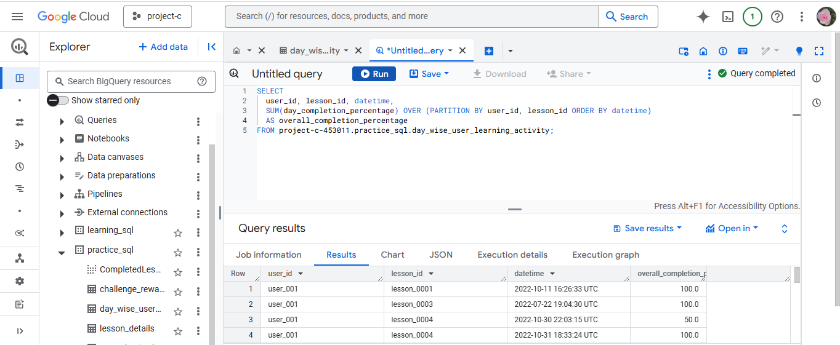

1. For each lesson, calculate the average overall_completion_percentage and rank the lessons based on this average.

(Consider the maximum overall completion percentage of a lesson by each user)

Expected output : | lesson_id | average_completion_percentage | rank_of_lesson |

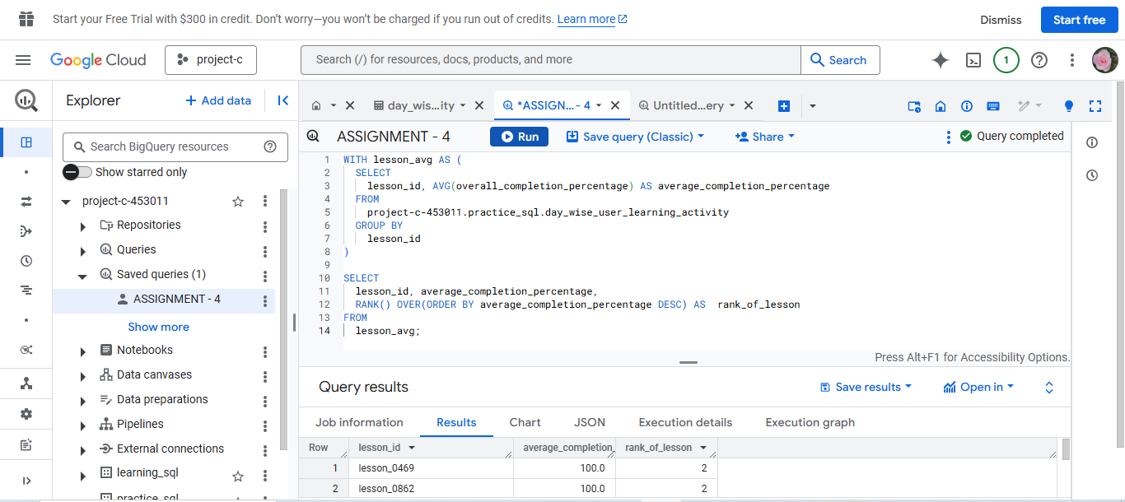

1. For each user and lesson, identify the lesson start date and lesson end date/latest progress date.

Expected output : | user_id | lesson_id | lesson_start_date | lesson_end_or_last_progress_date |

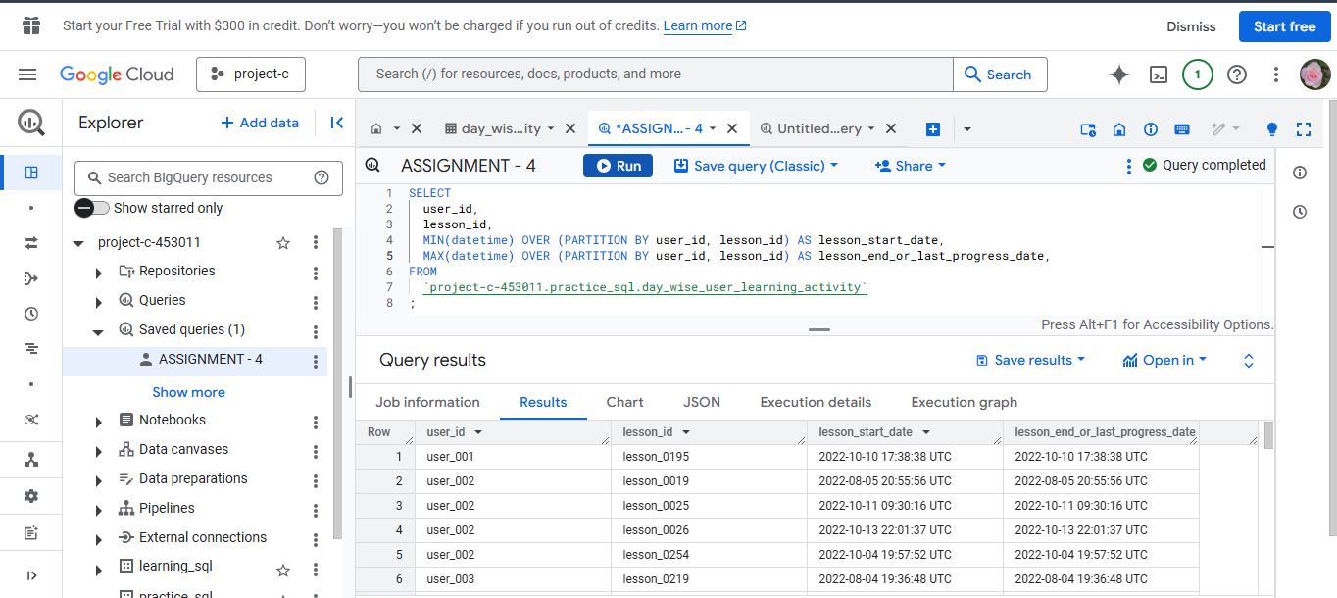

1. Pivot the overall_completion_percentage by lesson_id for each user. Show a row for each user_id and columns for each lesson_id.

Expected Output : | user_id | lesson_1_completion_percentage | lesson_2_completion_percentage |

Till lesson_5. Ignore the rest of the lessons

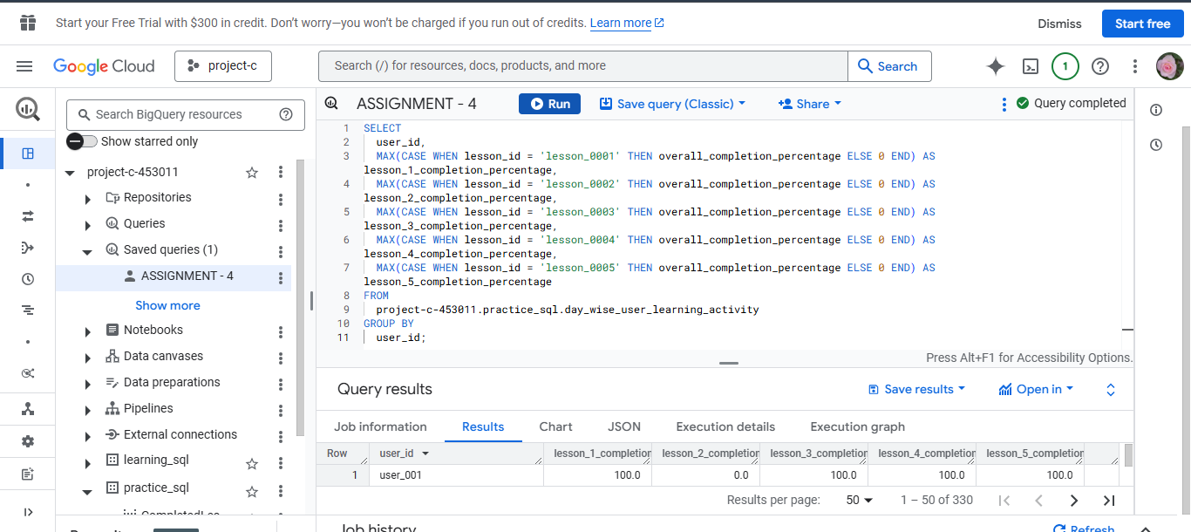

1. Rank lession_id wise completed users based on their completion datetime.

Expected output : | lesson_id | user_id | rank |

Order the output based on lesson_id and rank

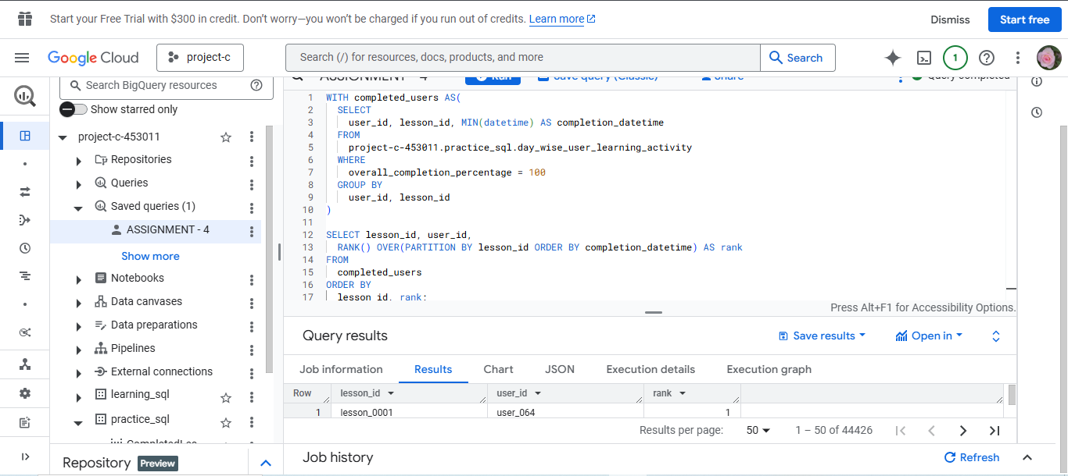

1. Determine the sequence in which each user completed their lessons. Provide the order of completion for each user_id and lesson_id.

Expected output : | user_id | lesson_id | order_of_completion |

Order the output by user_id and order_of_completion

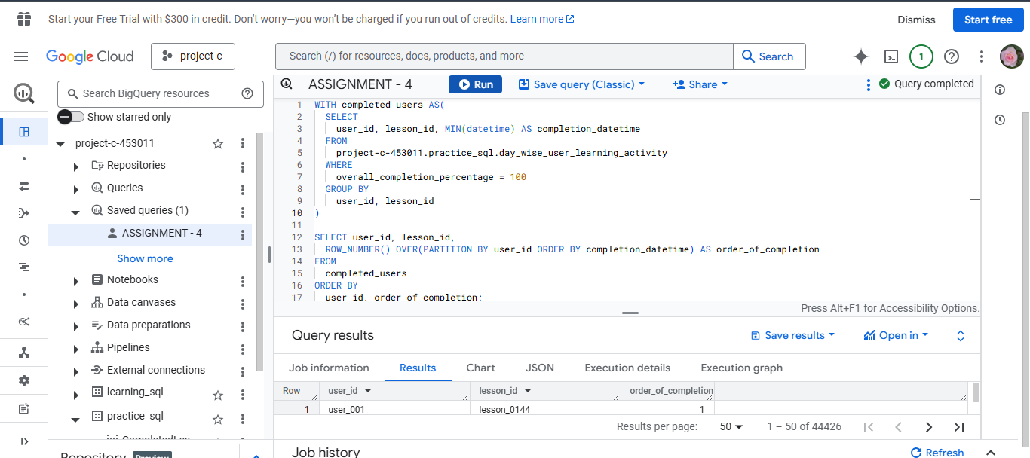

1. For each lesson_id and user id, get the user who completed before him and the user who completed after him

Expected output : | lesson_id | user_id | rank_of_user | previous_user_who_completed | next_user_who_completed |

If there is no next user / previous user who completed a lesson, show it as “No User” instead of keeping it as null

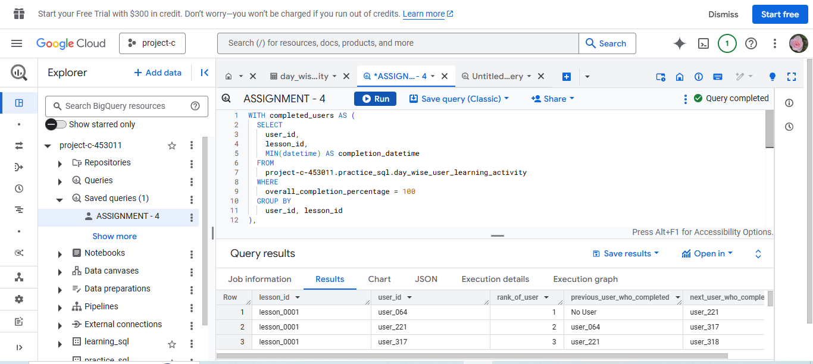

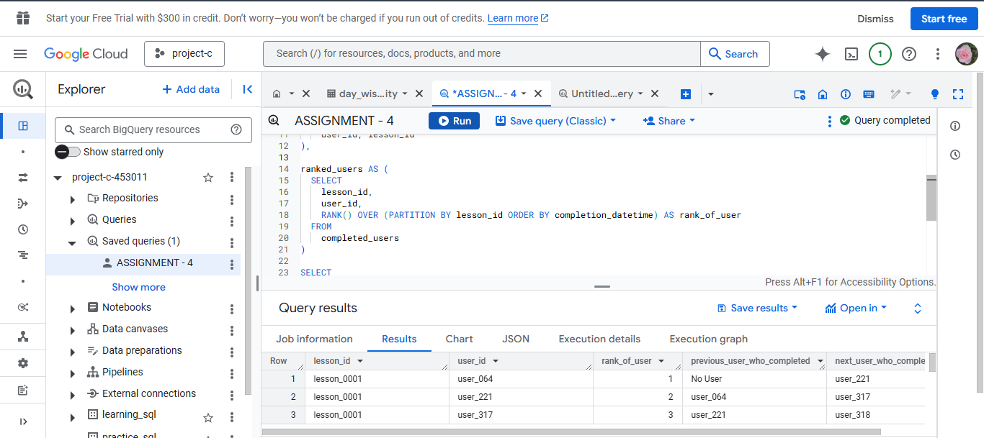

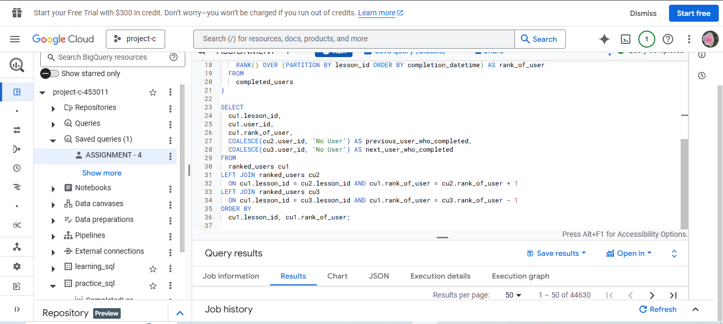

1. For each lesson, get the user who is the 4th person to complete the lesson

Expected output : | lesson_id | fourth_person_who_completed |

If multiple users have completed at same time, get all those users (A lesson may have more than 1 row in this case)

